Convex Uniform Polyhedra

Definition
# Source: AI Source: Provided by: [Data Path: Persons Table -> ID Column: 1, Name_En Column: Motasem Essam] -> From: [ChatGPT] on [7/25/2026]
A Convex Uniform Polyhedron is a convex polyhedron whose faces are regular polygons and whose vertices are all geometrically equivalent under the symmetries of the solid.
Every convex uniform polyhedron satisfies two fundamental conditions:
- Regular Faces: Every face is a regular convex polygon.
- Vertex Transitivity: A symmetry operation of the polyhedron can map any vertex onto any other vertex.
Convex uniform polyhedra include the five Platonic solids, the thirteen Archimedean solids, and two infinite families: regular prisms and regular antiprisms.

Geometric Structure
# Source: AI Source: Provided by: [Data Path: Persons Table -> ID Column: 1, Name_En Column: Motasem Essam] -> From: [ChatGPT] on [7/25/2026]
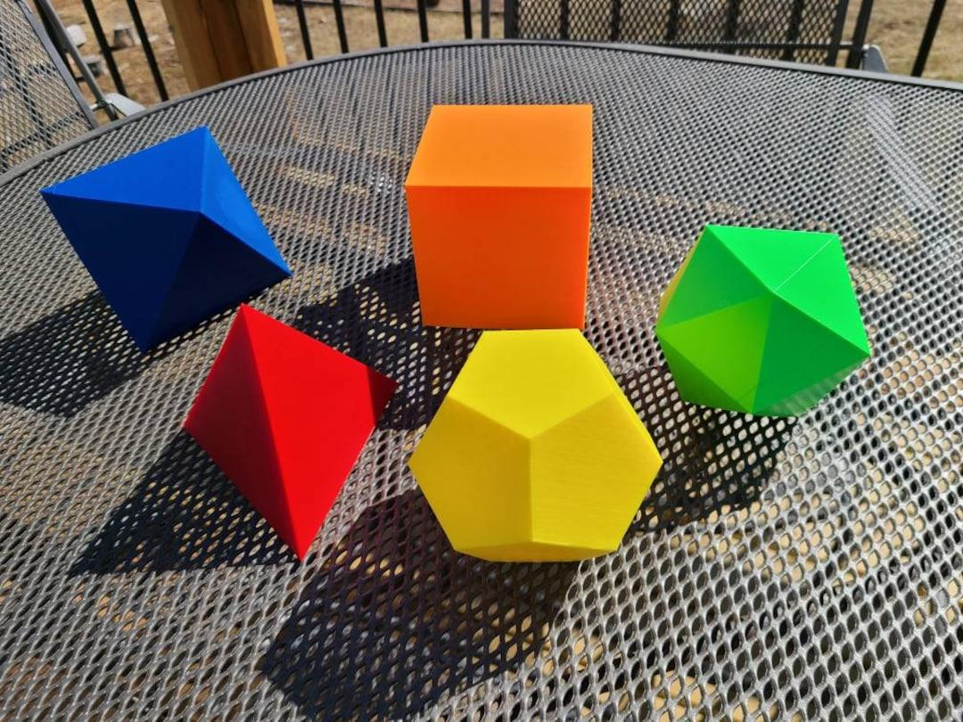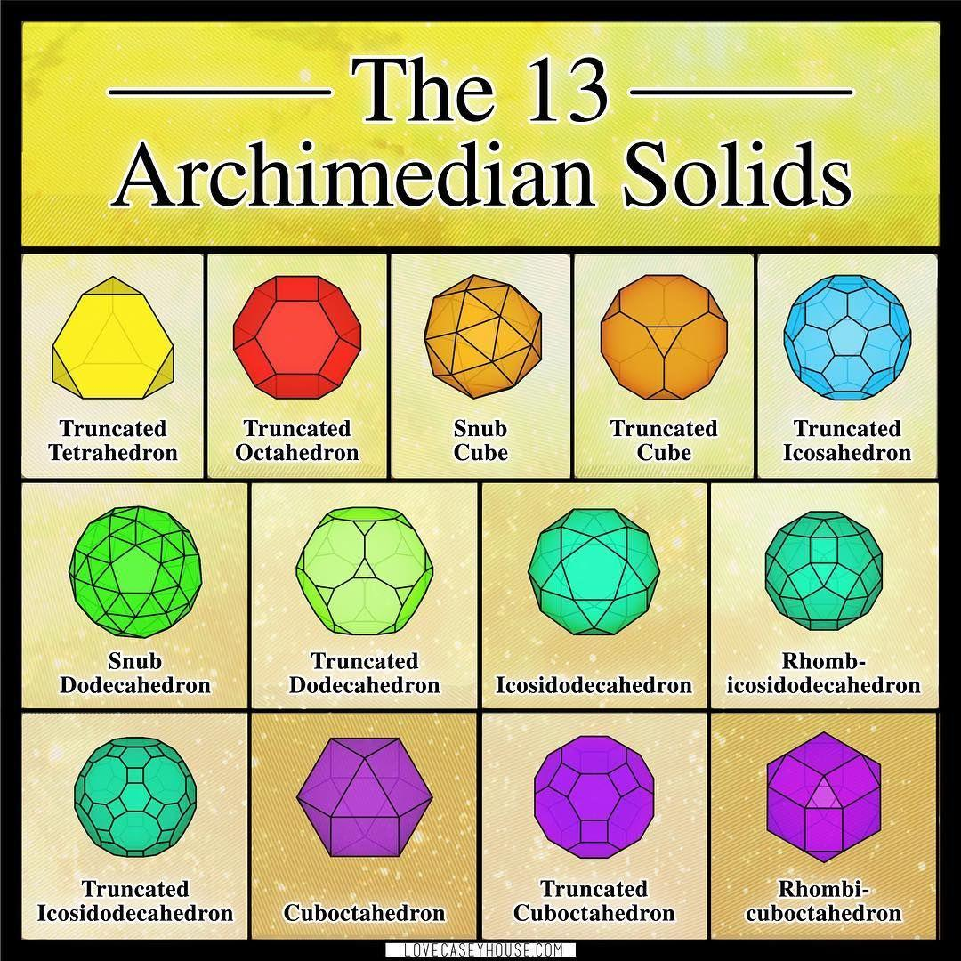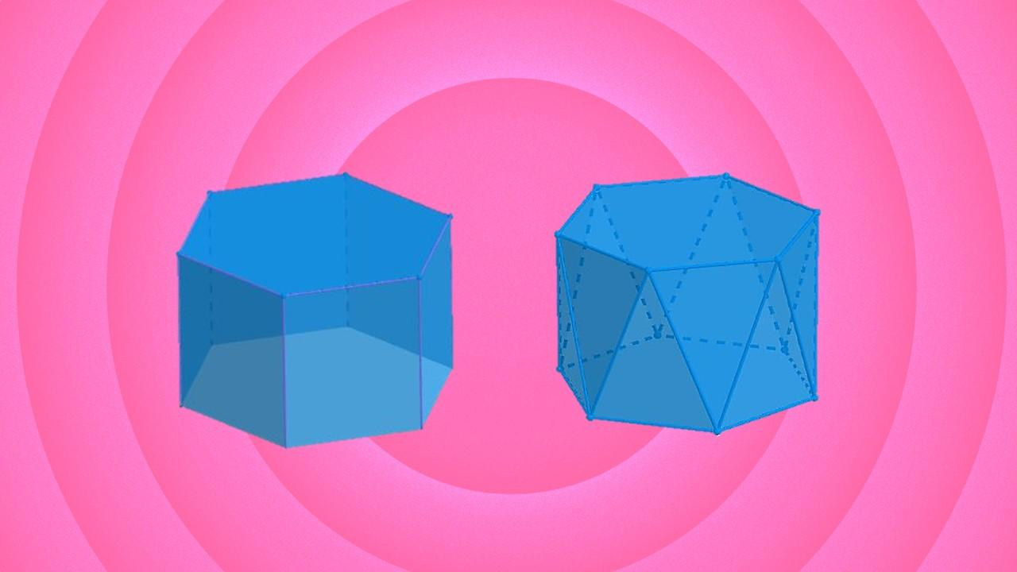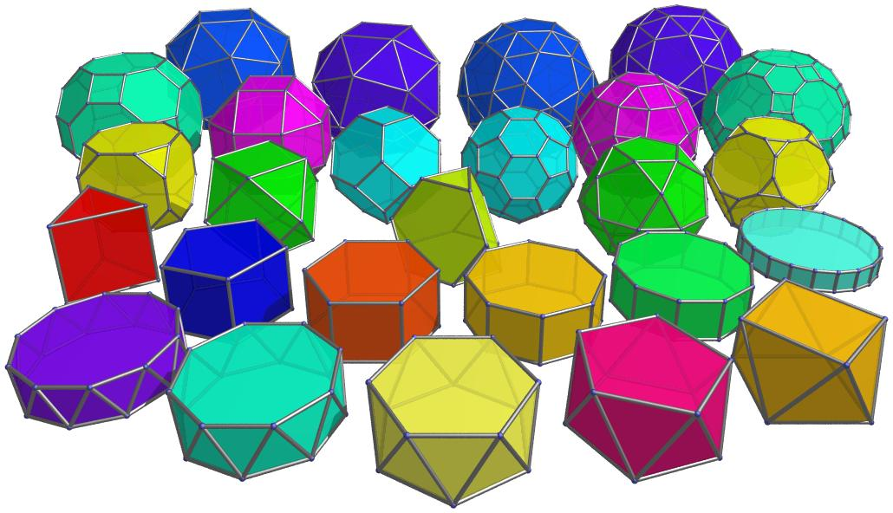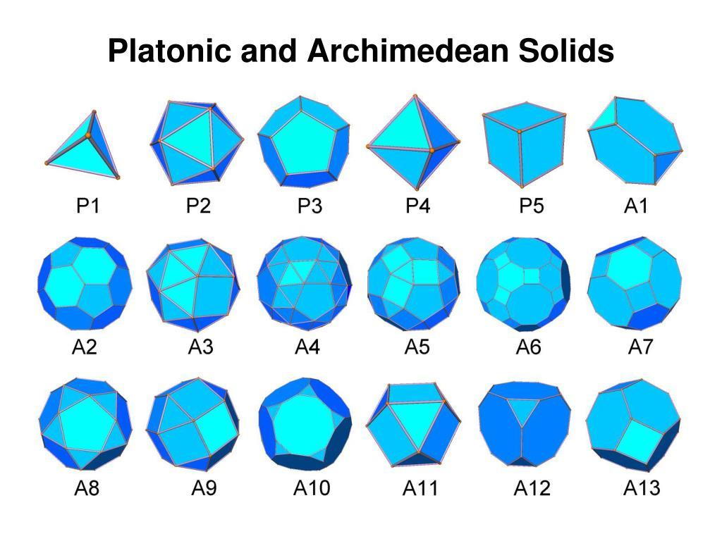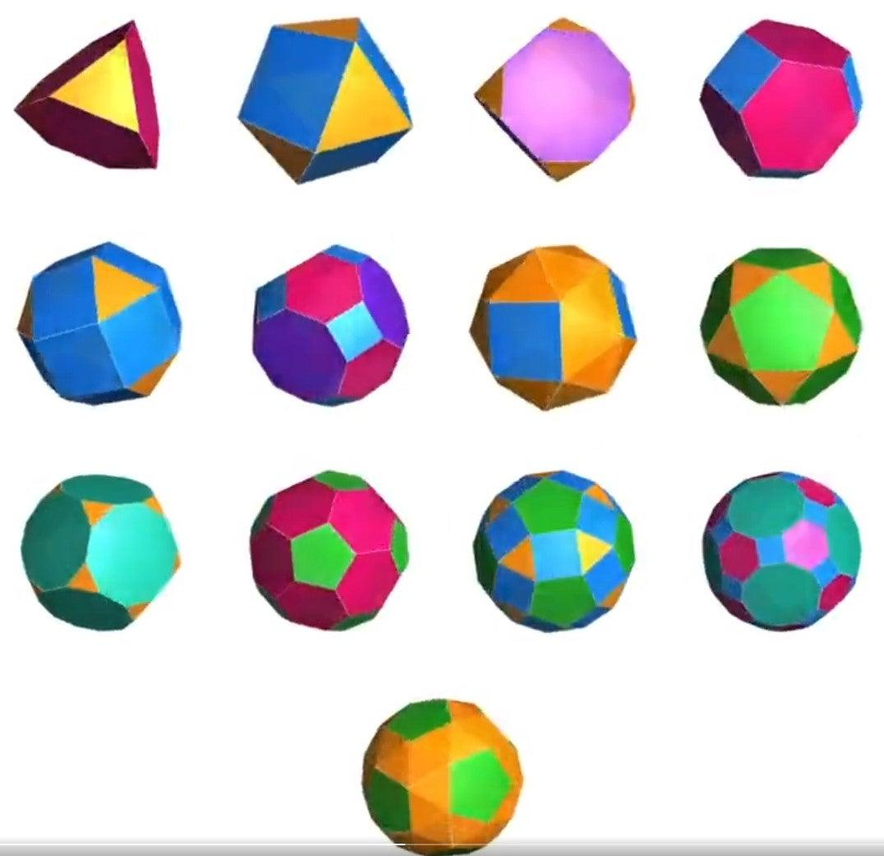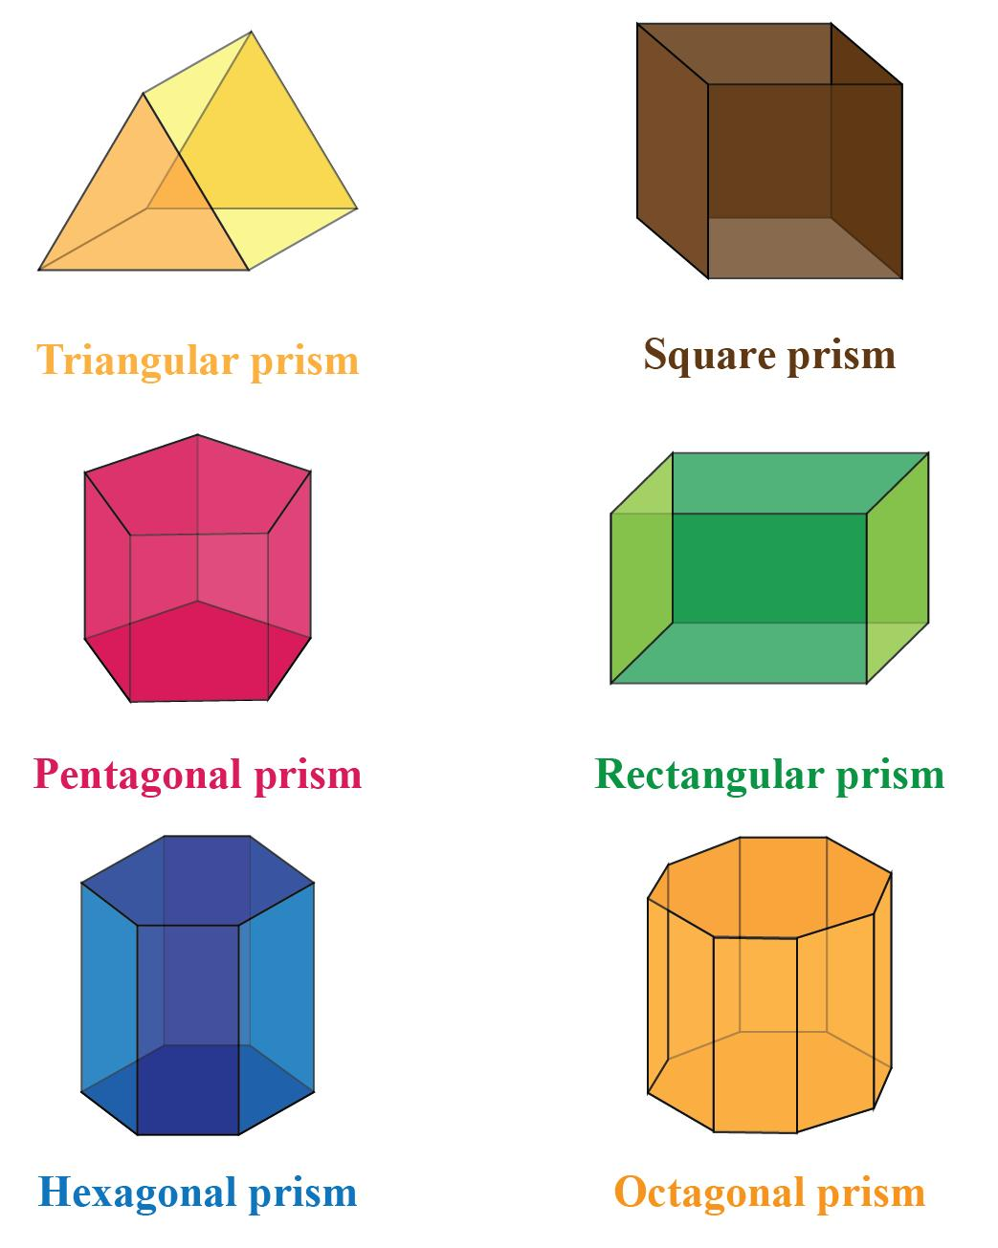
Convex uniform polyhedra have regular polygonal faces arranged symmetrically around every vertex.
Their faces meet without crossing or passing through the interior of the solid, and the entire polyhedron encloses a convex volume.

Mathematical Properties
# Source: AI Source: Provided by: [Data Path: Persons Table -> ID Column: 1, Name_En Column: Motasem Essam] -> From: [ChatGPT] on [7/25/2026]
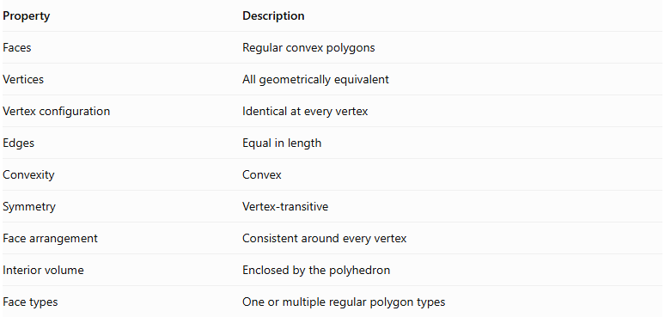
Property | Description
Faces | Regular convex polygons
Vertices | All geometrically equivalent
Vertex configuration | Identical at every vertex
Edges | Equal in length
Convexity | Convex
Symmetry | Vertex-transitive
Face arrangement | Consistent around every vertex
Interior volume | Enclosed by the polyhedron
Face types | One or multiple regular polygon types

Vertex Configuration
# Source: AI Source: Provided by: [Data Path: Persons Table -> ID Column: 1, Name_En Column: Motasem Essam] -> From: [ChatGPT] on [7/25/2026]
The vertex configuration describes the sequence of regular polygons meeting around each vertex.
Examples:
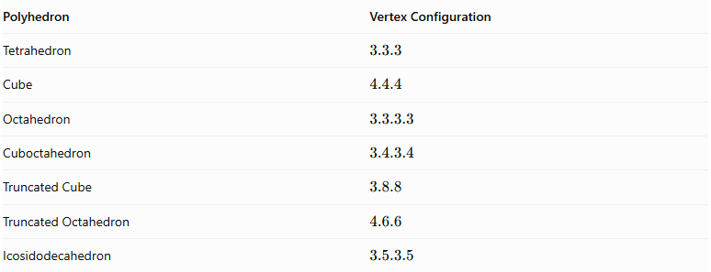
Polyhedron | Vertex Configuration
Tetrahedron | $$3.3.3$$
Cube | $$4.4.4$$
Octahedron | $$3.3.3.3$$
Cuboctahedron | $$3.4.3.4$$
Truncated Cube | $$3.8.8$$
Truncated Octahedron | $$4.6.6$$
Icosidodecahedron | $$3.5.3.5$$

Types of Convex Uniform Polyhedra
# Source: AI Source: Provided by: [Data Path: Persons Table -> ID Column: 1, Name_En Column: Motasem Essam] -> From: [ChatGPT] on [7/25/2026]
Convex uniform polyhedra are classified into three principal groups:
- Platonic Solids
- Archimedean Solids
- Uniform Prisms and Antiprisms

Platonic Solids
# Source: AI Source: Provided by: [Data Path: Persons Table -> ID Column: 1, Name_En Column: Motasem Essam] -> From: [ChatGPT] on [7/25/2026]
Platonic Solids are the five regular convex polyhedra. Every face is the same regular polygon, and the same number of faces meet at every vertex.
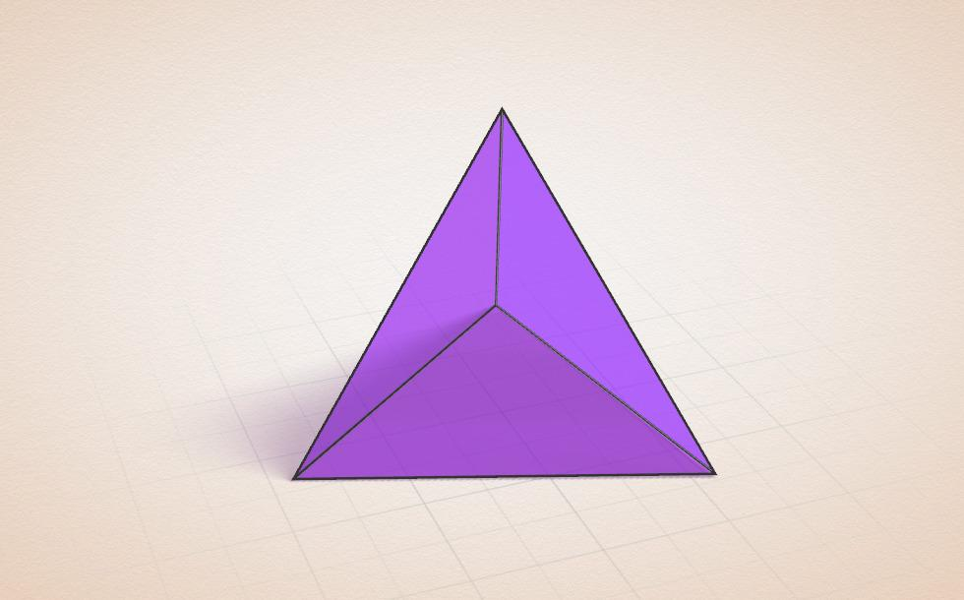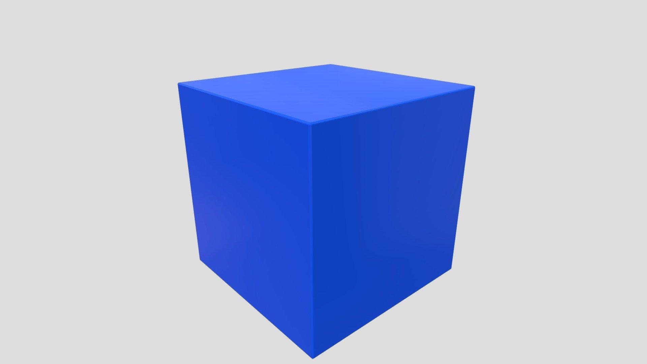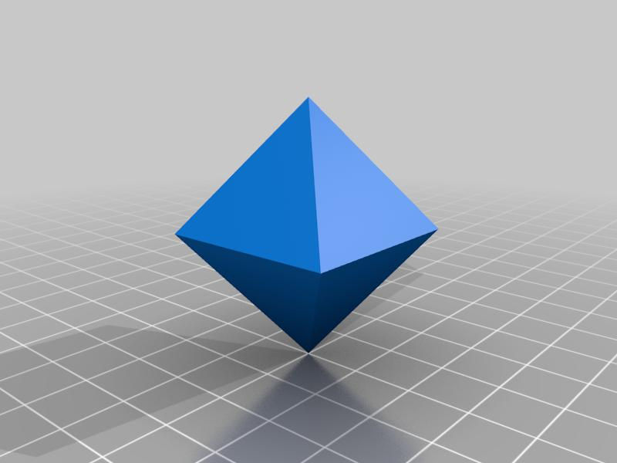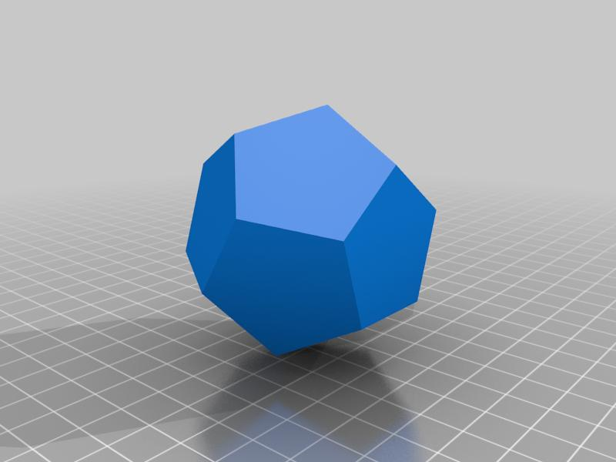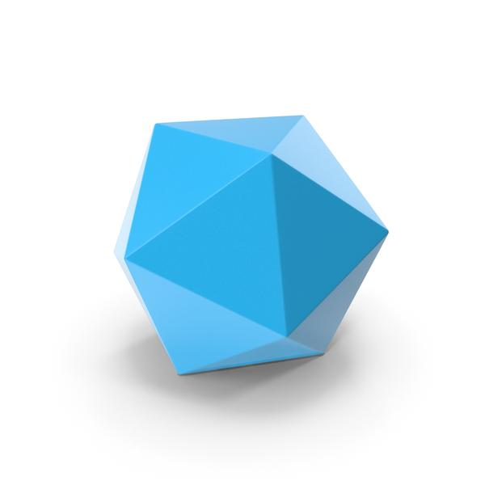
The five Platonic solids are:
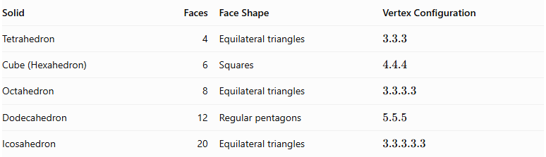
Solid | Faces | Face Shape | Vertex Configuration
Tetrahedron | 4 | Equilateral triangles | $$3.3.3$$
Cube (Hexahedron) | 6 | Squares | $$4.4.4$$
Octahedron | 8 | Equilateral triangles | $$3.3.3.3$$
Dodecahedron | 12 | Regular pentagons | $$5.5.5$$
Icosahedron | 20 | Equilateral triangles | $$3.3.3.3.3$$
Characteristics:
- All faces are congruent regular polygons.
- All edges have equal lengths.
- All vertices are equivalent.
- Every Platonic solid is a regular polyhedron.

Archimedean Solids
# Source: AI Source: Provided by: [Data Path: Persons Table -> ID Column: 1, Name_En Column: Motasem Essam] -> From: [ChatGPT] on [7/25/2026]
Archimedean Solids are thirteen convex uniform polyhedra whose faces consist of two or more types of regular polygons.
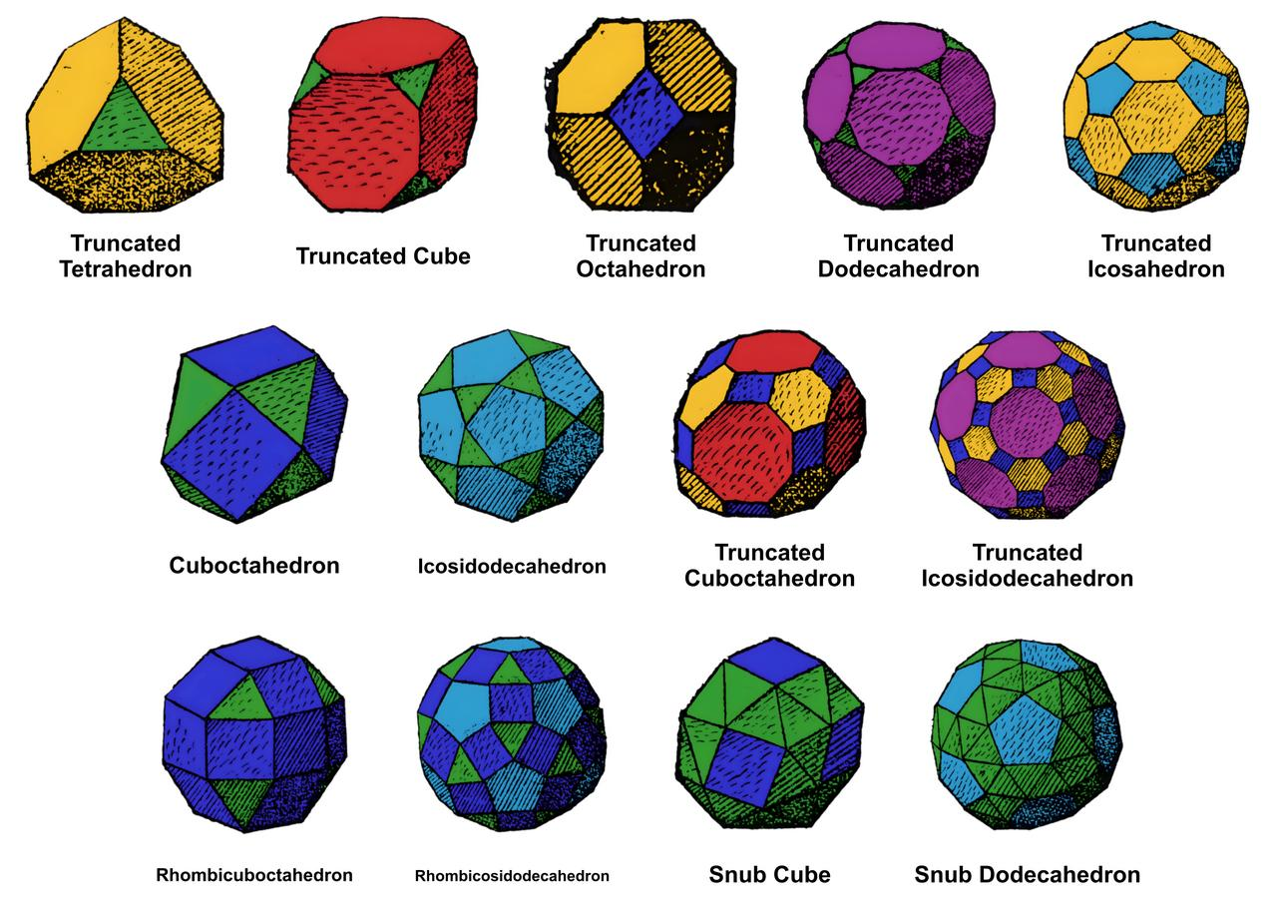
The thirteen Archimedean solids are:
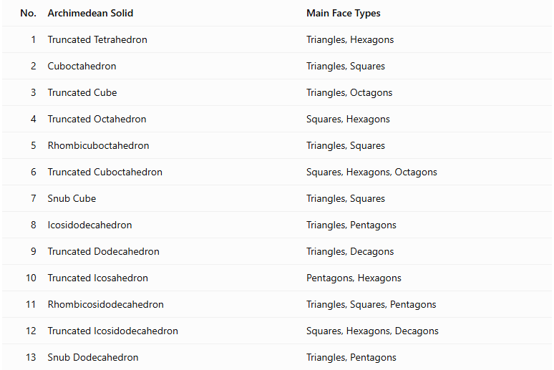
No. | Archimedean Solid | Main Face Types
1 | Truncated Tetrahedron | Triangles, Hexagons
2 | Cuboctahedron | Triangles, Squares
3 | Truncated Cube | Triangles, Octagons
4 | Truncated Octahedron | Squares, Hexagons
5 | Rhombicuboctahedron | Triangles, Squares
6 | Truncated Cuboctahedron | Squares, Hexagons, Octagons
7 | Snub Cube | Triangles, Squares
8 | Icosidodecahedron | Triangles, Pentagons
9 | Truncated Dodecahedron | Triangles, Decagons
10 | Truncated Icosahedron | Pentagons, Hexagons
11 | Rhombicosidodecahedron | Triangles, Squares, Pentagons
12 | Truncated Icosidodecahedron | Squares, Hexagons, Decagons
13 | Snub Dodecahedron | Triangles, Pentagons
Characteristics:
- Faces are regular polygons.
- Two or more polygon types may appear.
- Every vertex has the same face arrangement.
- All edges have equal lengths.
- They are convex and vertex-transitive.
- Two are quasiregular: the Cuboctahedron and Icosidodecahedron. The remaining eleven are semiregular.

Uniform Prisms
# Source: AI Source: Provided by: [Data Path: Persons Table -> ID Column: 1, Name_En Column: Motasem Essam] -> From: [ChatGPT] on [7/25/2026]
Uniform Prisms are an infinite family of convex uniform polyhedra formed by connecting two parallel, congruent regular polygonal bases with square lateral faces.
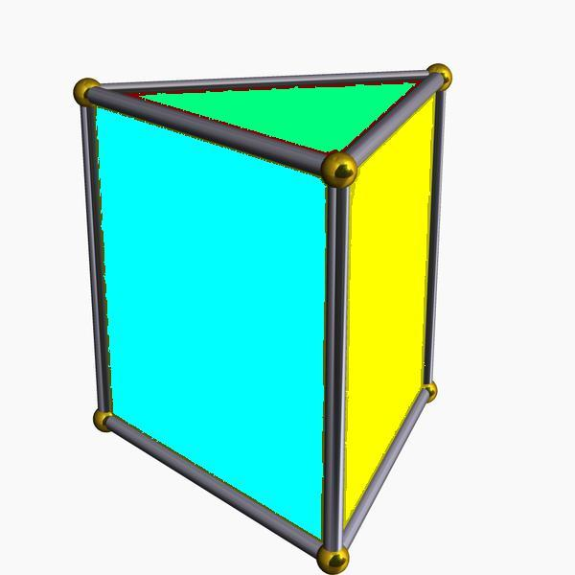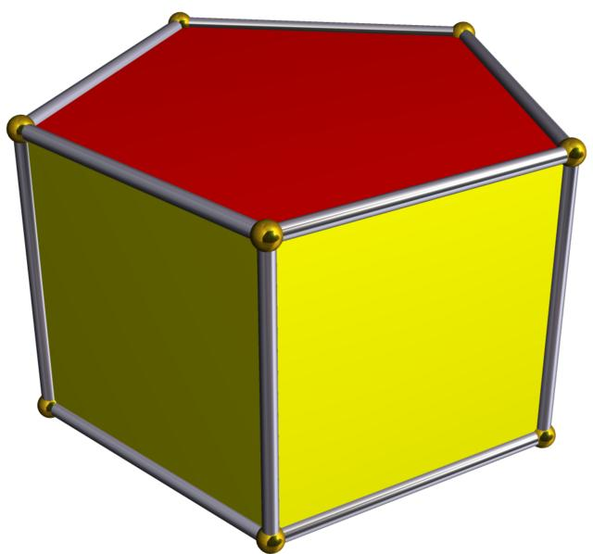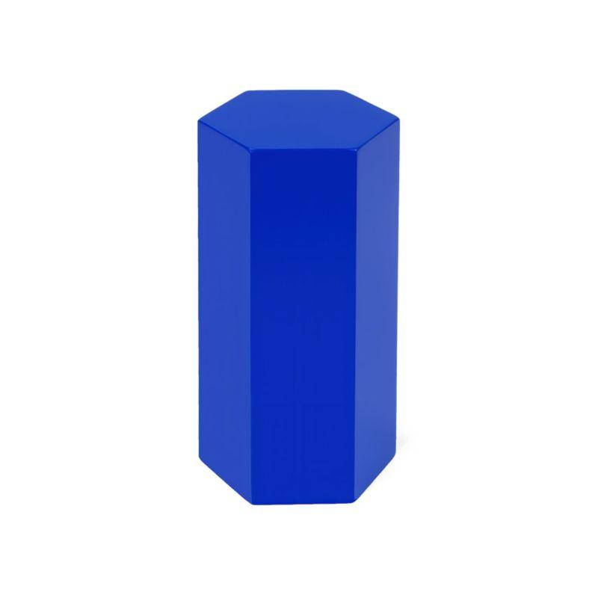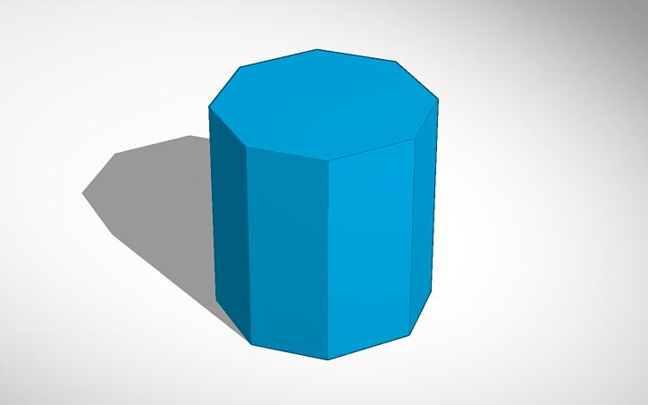

Types of Uniform Prisms
# Source: AI Source: Provided by: [Data Path: Persons Table -> ID Column: 1, Name_En Column: Motasem Essam] -> From: [ChatGPT] on [7/25/2026]
- Triangular Prism
- Square Prism
- Pentagonal Prism
- Hexagonal Prism
- Heptagonal Prism
- Octagonal Prism
- Nonagonal Prism
- Decagonal Prism
- N-gonal Prism
Characteristics:
- Both bases are congruent regular polygons.
- The bases are parallel.
- Lateral faces are squares.
- All edges have equal lengths.
- Every vertex has the same configuration.
For an $n$-gonal uniform prism:
$$F=n+2$$
$$E=3n$$
$$V=2n$$
The vertex configuration is:
$$3.4.4$$
For $n=4$, the square prism is the cube, which is already included among the Platonic solids.

Uniform Antiprisms
# Source: AI Source: Provided by: [Data Path: Persons Table -> ID Column: 1, Name_En Column: Motasem Essam] -> From: [ChatGPT] on [7/25/2026]
Uniform Antiprisms are an infinite family of convex uniform polyhedra formed by connecting two parallel, congruent regular polygonal bases with alternating equilateral triangular faces.
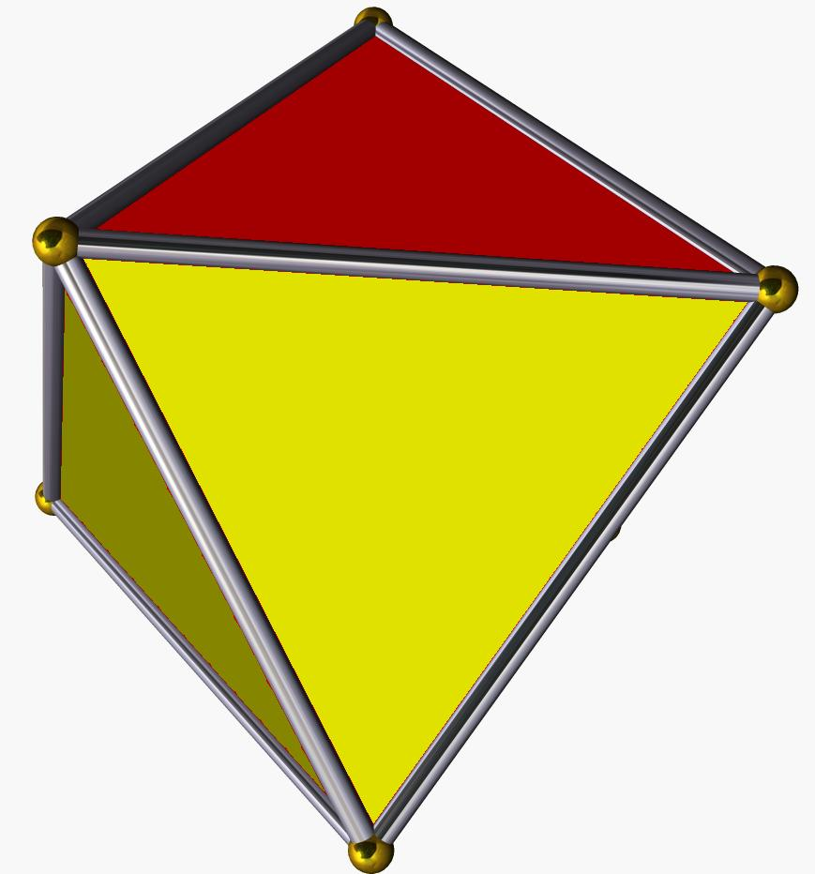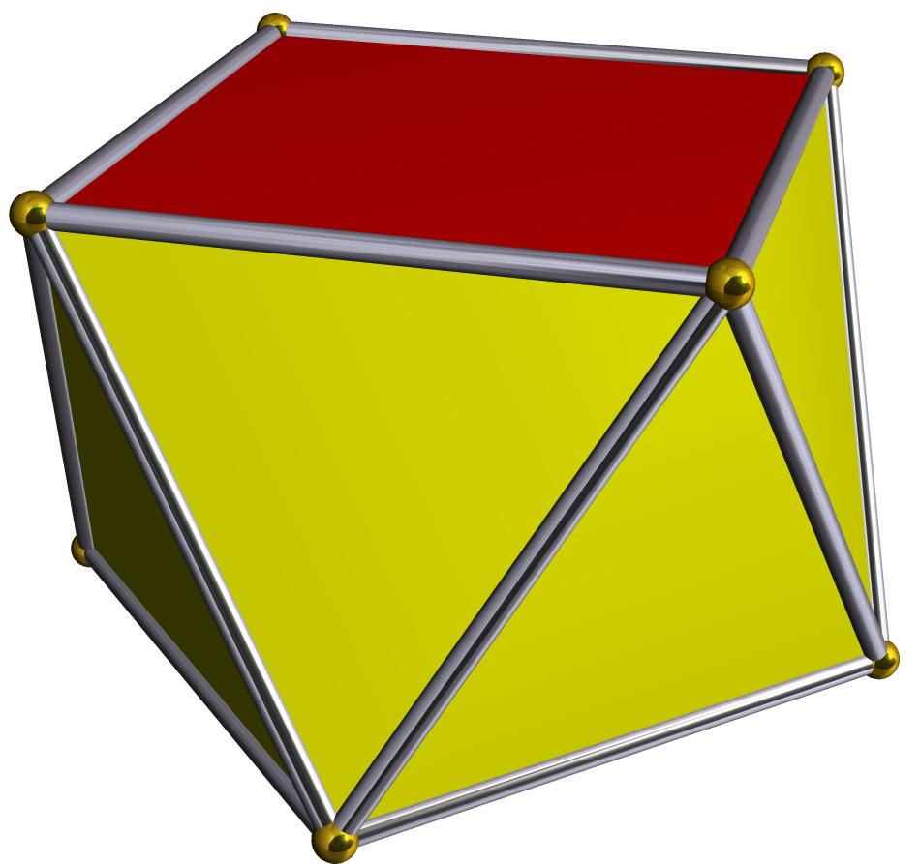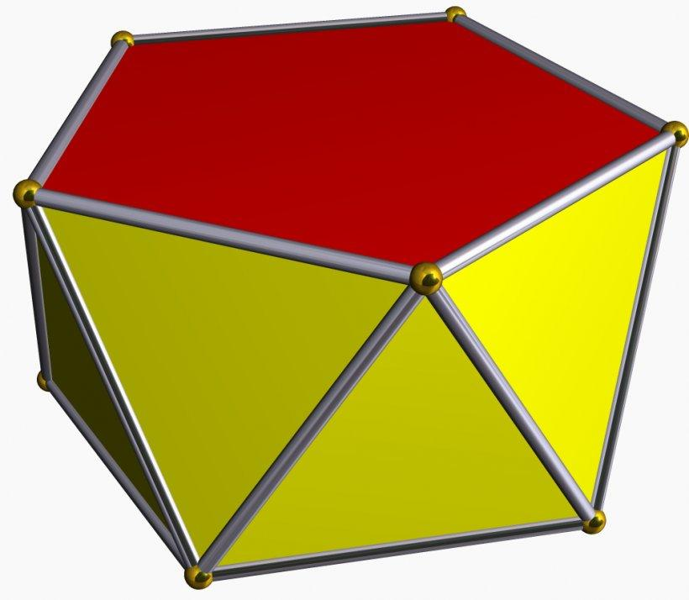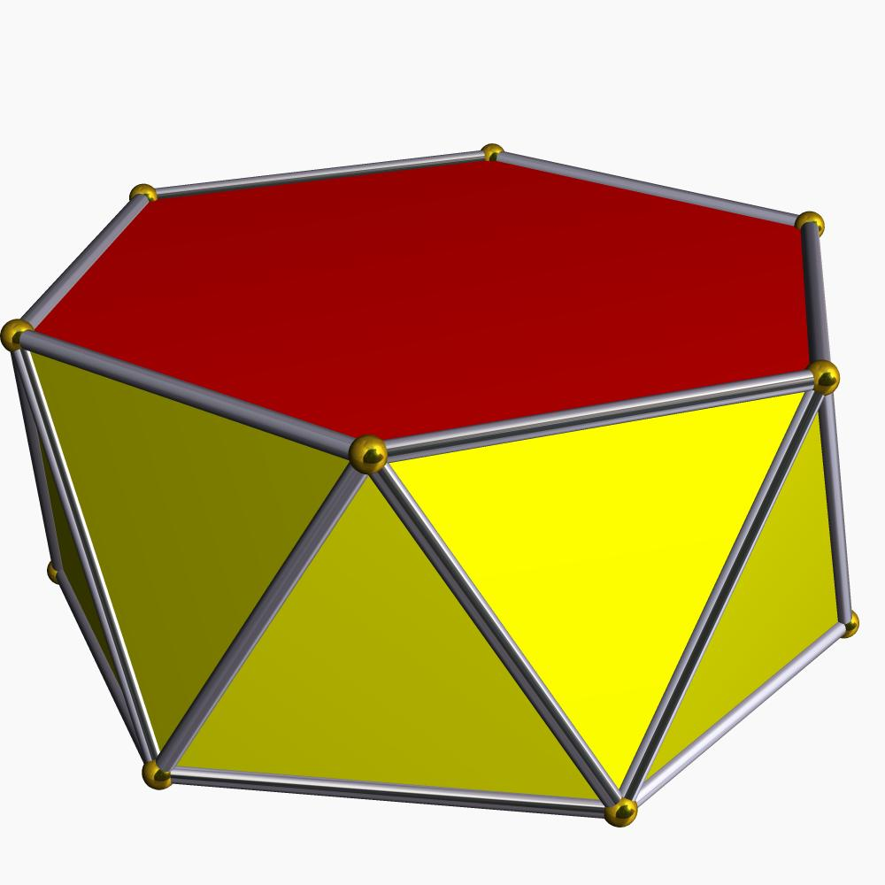

Types of Uniform Antiprisms
# Source: AI Source: Provided by: [Data Path: Persons Table -> ID Column: 1, Name_En Column: Motasem Essam] -> From: [ChatGPT] on [7/25/2026]
- Triangular Antiprism
- Square Antiprism
- Pentagonal Antiprism
- Hexagonal Antiprism
- Heptagonal Antiprism
- Octagonal Antiprism
- Nonagonal Antiprism
- Decagonal Antiprism
- N-gonal Antiprism
Characteristics:
- Both bases are congruent regular polygons.
- The bases are parallel but relatively rotated.
- The lateral faces are equilateral triangles.
- All edges have equal lengths.
- Every vertex has the same configuration.
For an $n$-gonal uniform antiprism:
$$F=2n+2$$
$$E=4n$$
$$V=2n$$
The vertex configuration is:
$$3.3.3.3$$
For $n=3$, the triangular antiprism is the regular octahedron, already included among the Platonic solids.

Geometric Characteristics
# Source: AI Source: Provided by: [Data Path: Persons Table -> ID Column: 1, Name_En Column: Motasem Essam] -> From: [ChatGPT] on [7/25/2026]
- Convexity: All convex uniform polyhedra have convex shapes without inward indentations.
- Regular Faces: Every face is a regular convex polygon.
- Equal Edges: All edges have equal lengths.
- Vertex Transitivity: Every vertex can be mapped onto any other vertex through a symmetry operation.
- Vertex Configuration: The same sequence of faces surrounds every vertex.
- Symmetry: They possess rotational and reflectional symmetries, although some have chiral forms.
- Face Diversity: They may have one or several types of regular polygonal faces.
- Finite and Infinite Families: Platonic and Archimedean solids are finite families, while prisms and antiprisms form infinite families.

Mathematical Classification
# Source: AI Source: Provided by: [Data Path: Persons Table -> ID Column: 1, Name_En Column: Motasem Essam] -> From: [ChatGPT] on [7/25/2026]
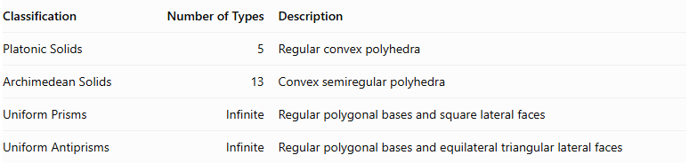
Classification | Number of Types | Description
Platonic Solids | 5 | Regular convex polyhedra
Archimedean Solids | 13 | Convex semiregular polyhedra
Uniform Prisms | Infinite | Regular polygonal bases and square lateral faces
Uniform Antiprisms | Infinite | Regular polygonal bases and equilateral triangular lateral faces
Counting note: The four groups are useful taxonomy categories, but they are not completely disjoint. The square prism is the cube, and the triangular antiprism is the octahedron. These are already counted among the Platonic solids.

Related Geometric Solids
# Source: AI Source: Provided by: [Data Path: Persons Table -> ID Column: 1, Name_En Column: Motasem Essam] -> From: [ChatGPT] on [7/25/2026]
- Non-Convex Uniform Polyhedra: Uniform polyhedra with non-convex geometry, including star polyhedra.
- Non-Uniform Polyhedra: Polyhedra that do not satisfy the uniformity requirements.
- Johnson Solids: Convex polyhedra with regular polygonal faces that are not uniform.
- Catalan Solids: The thirteen duals of the Archimedean solids.
- Regular Polyhedra: Polyhedra with identical regular faces and equivalent vertices and edges.
- Semiregular Polyhedra: A term commonly used for convex uniform polyhedra with multiple types of regular faces.

Main Classification
# Source: AI Source: Provided by: [Data Path: Persons Table -> ID Column: 1, Name_En Column: Motasem Essam] -> From: [ChatGPT] on [7/25/2026]
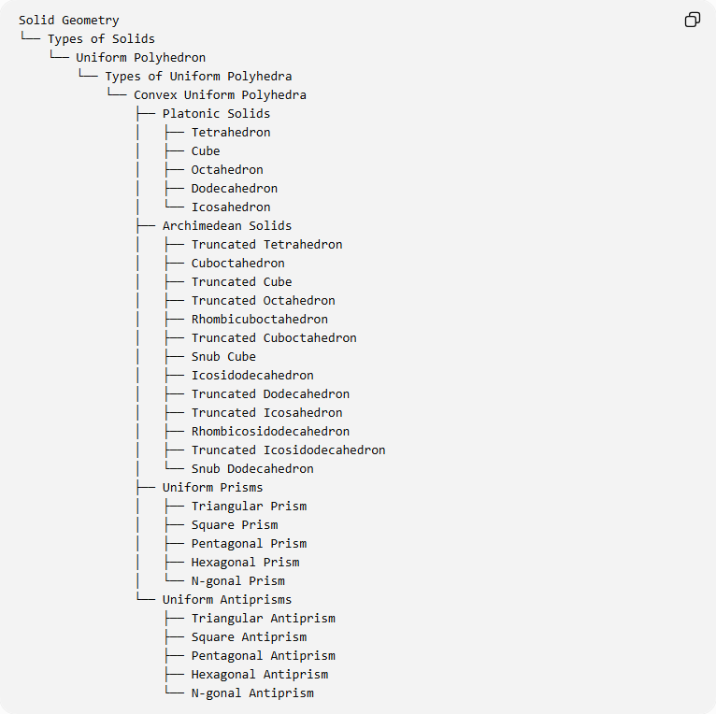
Solid Geometry
└── Types of Solids
└── Uniform Polyhedron
└── Types of Uniform Polyhedra
└── Convex Uniform Polyhedra
├── Platonic Solids
│ ├── Tetrahedron
│ ├── Cube
│ ├── Octahedron
│ ├── Dodecahedron
│ └── Icosahedron
├── Archimedean Solids
│ ├── Truncated Tetrahedron
│ ├── Cuboctahedron
│ ├── Truncated Cube
│ ├── Truncated Octahedron
│ ├── Rhombicuboctahedron
│ ├── Truncated Cuboctahedron
│ ├── Snub Cube
│ ├── Icosidodecahedron
│ ├── Truncated Dodecahedron
│ ├── Truncated Icosahedron
│ ├── Rhombicosidodecahedron
│ ├── Truncated Icosidodecahedron
│ └── Snub Dodecahedron
├── Uniform Prisms
│ ├── Triangular Prism
│ ├── Square Prism
│ ├── Pentagonal Prism
│ ├── Hexagonal Prism
│ └── N-gonal Prism
└── Uniform Antiprisms
├── Triangular Antiprism
├── Square Antiprism
├── Pentagonal Antiprism
├── Hexagonal Antiprism
└── N-gonal Antiprism

Key Points
# Source: AI Source: Provided by: [Data Path: Persons Table -> ID Column: 1, Name_En Column: Motasem Essam] -> From: [ChatGPT] on [7/25/2026]
- Convex uniform polyhedra have regular convex polygonal faces.
- Every vertex is geometrically equivalent under the symmetries of the solid.
- There are five Platonic solids and thirteen Archimedean solids.
- Regular prisms and antiprisms form two infinite families.
- The Platonic solids are also regular uniform polyhedra.
- The Archimedean solids are convex semiregular uniform polyhedra.
- Johnson solids are not uniform polyhedra.
- The square prism and triangular antiprism are special cases that coincide with the cube and octahedron, respectively.

Conclusion
# Source: AI Source: Provided by: [Data Path: Persons Table -> ID Column: 1, Name_En Column: Motasem Essam] -> From: [ChatGPT] on [7/25/2026]
A Convex Uniform Polyhedron is a convex solid with regular polygonal faces and vertex-transitive symmetry. Its classification includes the Platonic solids, Archimedean solids, uniform prisms, and uniform antiprisms.

